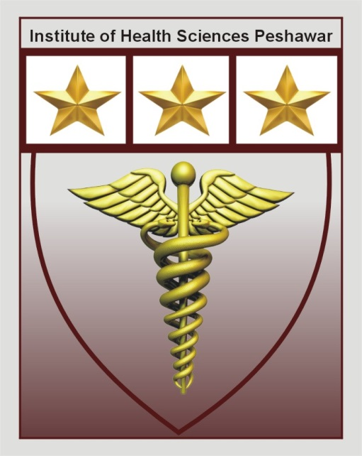
Institute Of Health Sciences
Peshawar
CAREER OPPORTUNITIES
Position | Qualification | No of Post | Experience | Gender
Lecturer  (DT) | BS-DT | 2 | 2 year  (Teaching Experience) | Male/Female
Lecturer  (DPT) | DPT | 2 | 2 year  (Teaching Experience) | Male/Female
Lecturer  (MLT) | BS-MLT | 2 | 2 year  (Teaching Experience) | Male/Female

- Last date to apply is Thursday 1st April, 2021.
- Shortlisted Candidates will be called for Demo/Test and interview on Thursday 8th April, 2021.
- Mail your resume on hr@ihs.edu.pk or drop at admin office on or before due date.
- IHS is an equal opportunity employer.

Institute of health sciences near Hayatabad toll plaza ring road Peshawar

