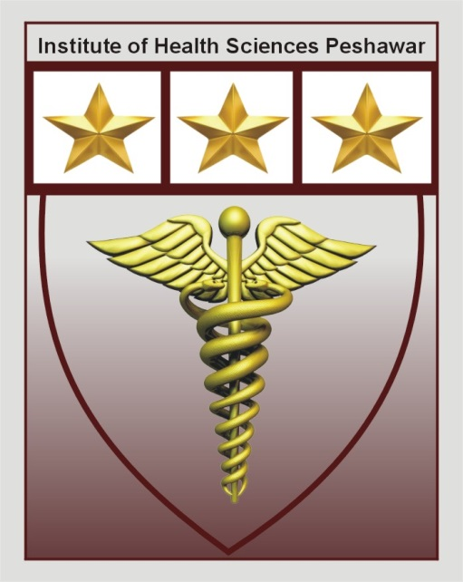
Institute Of Health Sciences Peshawar
Career Opportunity
Position | Qualification | Experience | Gender
Assistant Professor  (Medical Lab Technology) | BS-MLT  MLSc/MS  (Medical Lab Technology) | 3-year (min)  (Teaching Experiences) | Male/Female
Lecturer  (Medical Lab Technology) | BS-MLT  (Medical Lab Technology) | 1-2 years  (Teaching Experiences) | Male/Female
Assistant Professor  (Dental Technology) | BDS  MCPS/MS | 3-year (min)  (Teaching Experiences) | Male/Female
Lecturer  (Dental Technology) | BS-DT  (Dental Technology) | 1-2 years  (Teaching Experiences) | Male/Female

- Last date to apply is Friday 19th July 2019.
- Candidates will be called for Demo/Test and interview
- Mail your resume at ihspeshawar@gmail.com or drop at admin office before or on due date.

Institute of health sciences near Hayatabad toll plaza ring road Peshawar
Phone: 091-5829536 Email:ihspeshawar@gmail.com

