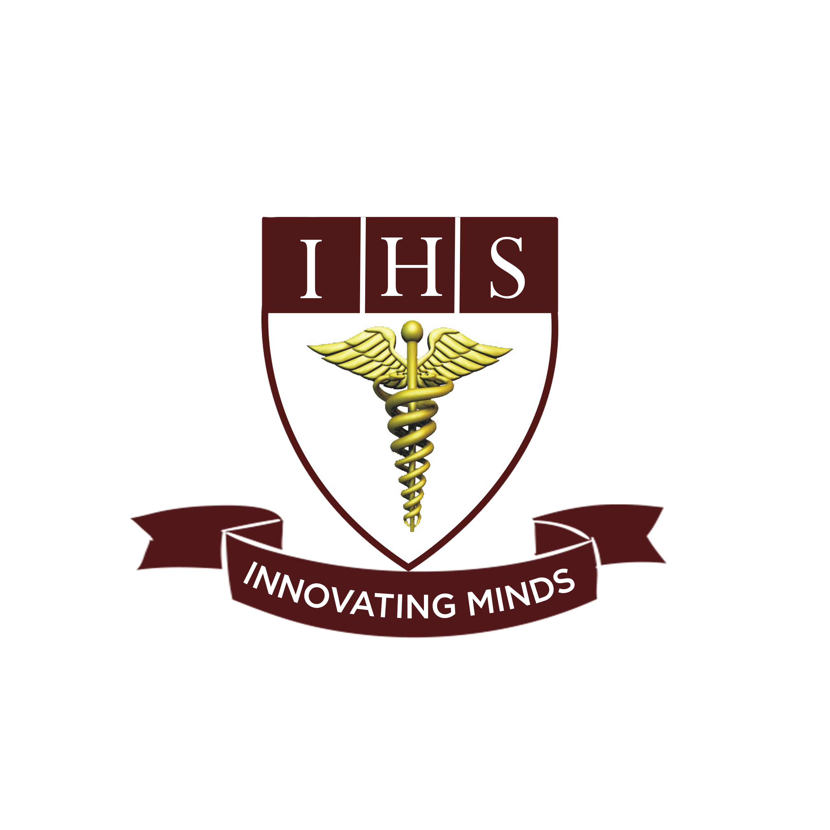
Institute Of Health Sciences
Peshawar
CAREER OPPORTUNITIES
Position | Qualification | No of Post | Experience | Gender
Lecturer  (Nursing) | BSN | 4 | Fresh Students can Apply | Male/Female

- Last date to apply is Thursday 2nd September, 2021.
- Shortlisted Candidates will be called for Demo/Test and interview.
- Mail your resume on info@ihs.edu.pk or drop at admin office on or before due date.
- IHS is an equal opportunity employer.

Institute of health sciences near Hayatabad toll plaza ring road Peshawar

